## Artificial Intelligence and

## Machine Learning

Project Report

Semester-IV (Batch-2022)

**CV Analysis**

**Supervised By: Submitted By:**

Mrs Monica Dutta Nikhil 2210990609

Nampreet Singh 2210990596

Narinder Singh 2210990598

Nipun Kumar 2210990615

**Department of Computer Science and Engineering**

**Chitkara University Institute of Engineering & Technology,**

**Chitkara University, Punjab**

**1. Introduction**

In the recruitment industry, manual CV screening is labor-intensive and prone to errors and biases. This project aims to develop an automated CV analysis system using AI and ML techniques. By accurately classifying and ranking CVs based on relevant criteria, the system enhances efficiency, reduces costs, and ensures fairer evaluations. Furthermore, this endeavor holds promise for revolutionizing HR practices and reshaping the future of workforce management. Leveraging advancements in natural language processing, the project contributes to the ongoing evolution of AI-driven decision-making systems, fostering innovation in talent acquisition and HR technology.

**1.1 Background**

The recruitment industry heavily relies on manual CV screening, a process prone to inefficiencies and biases. With an increasing volume of job applications, recruiters face challenges in effectively identifying qualified candidates. Traditional methods are labor-intensive and subject to human error, often resulting in overlooked talents. Automation through AI and ML presents a solution to streamline this process. By harnessing natural language processing and machine learning techniques, automated CV analysis systems offer a more efficient and objective approach. These systems not only save time and resources but also ensure fairer evaluations, contributing to improved hiring decisions and workforce quality.

**1.2 Motivation**

Amidst the challenges prevalent in manual CV screening within the recruitment sector, our project is fueled by the imperative to rectify the inefficiencies and biases inherent in conventional practices. With the escalating influx of job applications, the need for a streamlined and impartial screening process has become increasingly pressing. Harnessing the transformative potential of AI and ML technologies, our objective is to craft an automated CV analysis system. Through this endeavor, we aspire not only to bolster efficiency but also to engender fairer evaluations. Our motivation is deeply rooted in the ambition to overhaul HR practices, elevate the caliber of candidate selection, and catalyze the evolution of workforce management in the digital era. Ultimately, our aim is to empower recruiters with the requisite tools to make discerning and impactful hiring decisions, thereby optimizing resource allocation and fostering organizational growth.

**1.3 Objective**

Embarking on this project, our aim is to engineer an automated CV analysis system employing AI and ML methodologies. This system is designed to optimize the initial screening of CVs by meticulously categorizing and prioritizing them based on pertinent criteria. Our overarching goal is to streamline the recruitment process, ameliorate operational costs, and foster equitable candidate assessments. Furthermore, we endeavor to conduct a comprehensive assessment of the system's performance using diverse metrics, encompassing accuracy, precision, and recall. Beyond operational efficacy, our project harbors aspirations of advancing the frontiers of AI through the application of sophisticated natural language processing techniques. By delving into this realm, we aspire to pioneer novel paradigms in automated decision-making systems, particularly within the domain of CV analysis. In essence, our mission is to develop a resilient and scalable solution capable of revolutionizing CV screening processes in recruitment, while concurrently pushing the boundaries of AI innovation.

**1.4 Scope**

Commencing our project, we define its scope to center on crafting an automated CV analysis system specifically tailored for refining initial screening processes within the recruitment sector. Our primary objective is to devise and implement AI and ML algorithms capable of meticulously classifying and ranking CVs based on predetermined criteria. While the system primarily operates on text-based CVs, it flexibly accommodates various formats and layouts commonly encountered in practice. It's important to note that our project does not encompass the entirety of the recruitment process, excluding facets such as interview scheduling and candidate communication. Moreover, the system's analysis is confined to textual content, potentially overlooking non-standard formats or multimedia elements within CVs. By adhering to these parameters, we strive to develop a robust solution that significantly elevates the efficiency and efficacy of CV screening processes while being mindful of practical constraints.

**1.5 Significance of the Project**

The project holds significant promise in reshaping the landscape of recruitment by addressing the shortcomings of manual CV screening processes. Through the automation of CV analysis using AI and ML techniques, our endeavor aims to not only streamline the initial screening process but also mitigate biases, enhance efficiency, and reduce operational costs. Moreover, this project represents a pioneering effort in advancing the field of AI, particularly in natural language processing and automated decision-making systems. Beyond its immediate impact on recruitment practices, the implementation of an automated CV analysis system carries broader implications for HR management, potentially leading to more informed hiring decisions, improved workforce diversity, and heightened organizational performance. In essence, our project stands poised to usher in a new era of efficiency, objectivity, and equity in candidate selection processes within the recruitment domain.

**2. Problem Definition and Requirement**

**2.1 Problem Statement**

In the recruitment industry, manual CV screening processes are labor-intensive, time-consuming, and prone to biases, leading to inefficiencies and potentially overlooking qualified candidates. The sheer volume of job applications exacerbates these challenges, further complicating the candidate selection process. Traditional methods lack scalability and often result in subjective evaluations, hindering the identification of the best-suited candidates for job positions. Thus, there is a pressing need for a more streamlined, objective, and scalable solution to automate the CV analysis process. This project seeks to address these challenges by developing an automated CV analysis system using AI and ML techniques, aiming to enhance efficiency, reduce biases, and improve the overall effectiveness of candidate screening in the recruitment process.

**2.2 Software Requirements**

The development and implementation of the customer churn prediction model require the following software tools and technologies:

* Operating System: Windows 10 or later / macOS Catalina or later / Linux (Ubuntu 18.04 or later).
* Programming Language: Python or R for data preprocessing, analysis, and model development.
* Data Analysis Libraries: Pandas, NumPy, Seaborn and Matplotlib for data manipulation and analysis.
* Machine Learning Libraries: Scikit-learn, TensorFlow for building and training predictive models.
* Visualization Tools: Plotly for data visualization and model performance evaluation.
* Integrated Development Environment (IDE): Jupyter Notebook or Google Colab for interactive development and experimentation.
* Version Control: Git for managing code versions and collaboration among team members.

**2.3 Hardware Requirements**

The hardware requirements for developing and deploying the customer churn prediction model are relatively modest and can be accommodated by standard computing devices, including:

* Processor: Intel Core i5 or AMD equivalent (minimum), Intel Core i7 or AMD Ryzen 7 (recommended).
* Memory: Minimum 8GB RAM for handling large datasets and running machine learning algorithms.
* Storage: Adequate storage space (at least 256GB SSD with at least 20GB free space) for storing datasets and code.
* Graphics Processing Unit (GPU): NVIDIA GeForce GTX or RTX series.
* Internet Connection: Stable internet connection for accessing online resources, libraries, and datasets.

**2.4 Data Sets**

The success of a CV analysis model relies heavily on the quality and relevance of the dataset used for training and evaluation. An ideal dataset for CV analysis should include diverse and comprehensive resume data, which covers:

* Job Title/Category: Classification of resumes by job roles such as Data Scientist, Web Developer, Data Analyst, etc.
* Skills: Specific skills mentioned in the resumes, like programming languages, tools, and technologies.
* Education: Educational background details including degrees, institutions, and majors.
* Areas of Expertise: Specific areas of knowledge or specialization.
* Personal Information: Personal statements or other relevant sections of the resume.

The dataset should be well-structured, with each row representing an individual resume and columns for different sections or attributes. Proper preprocessing and cleaning of text data are crucial to ensure the model's effectiveness. Publicly available datasets from job portals and professional networking sites, as well as data from corporate HR systems, can provide valuable resume data for this analysis.

**3. Proposed Design/Methodology**

**3.1 Overview**

The proposed design involves developing a sophisticated machine learning model to categorize resumes based on their content, streamlining the recruitment process by automatically classifying resumes into predefined categories. The methodology includes extensive data preprocessing to clean and prepare the text data by removing irrelevant characters, URLs, and punctuation, converting text to lowercase, and eliminating stop words to reduce noise. Feature extraction using Term Frequency-Inverse Document Frequency (TF-IDF) transforms the text into numerical features, highlighting significant terms. Categorical variables, such as job roles, are encoded into a numerical format to facilitate their use in machine learning algorithms. The processed data is split into training and testing sets, allowing for robust model evaluation and ensuring generalization. Various classification algorithms, including Logistic Regression, Support Vector Machines (SVM), Decision Tree, will be evaluated based on metrics like accuracy, precision, recall, and F1 score to identify the best-performing model.

**3.2 Data Collection**

The dataset used for this project comprises resumes collected from various job portals and professional networking sites. Each resume is categorized into job roles such as Data Scientist, Web Developer, and Data Analyst. The dataset includes sections for skills, education, areas of expertise, and personal information. This diverse and comprehensive dataset provides a robust foundation for training and evaluating the CV analysis model.

**3.3 Data Preprocessing**

The dataset undergoes several comprehensive preprocessing steps to ensure its suitability for model training and evaluation. Initially, text cleaning is performed to remove irrelevant characters, URLs, and punctuation, eliminating extraneous information that could introduce noise. Subsequently, normalization is applied by converting all text to lowercase, ensuring consistency by treating words like "Data" and "data" identically. Commonly used words that do not add significant meaning, known as stop words (e.g., "and", "the", "is"), are then removed, reducing dimensionality and emphasizing more informative terms. The cleaned and normalized text is tokenized, splitting it into individual words to facilitate further analysis. Categorical job roles within the dataset are encoded to transform categorical data into a numerical format suitable for machine learning algorithms. The textual data is then transformed using TF-IDF vectorization, which is split into training and testing sets, enabling robust model evaluation and ensuring the model's ability to generalize well to unseen data.

**3.4 Feature Engineering**

In the CV analysis project, robust feature engineering was pivotal for optimizing predictive performance. Raw CV data underwent meticulous preprocessing, including cleaning and normalization. Feature extraction via NLP techniques extracted pertinent details like skills and experience. Encoding and embedding transformed categorical and textual data for machine learning compatibility. Feature selection methods identified key predictors for candidate suitability. This rigorous process fortified the model's ability to discern patterns, ensuring enhanced accuracy and reliability in candidate evaluation and selection.

**3.5 Model Selection**

In selecting the optimal model for our CV analysis project, we embarked on a rigorous evaluation process to identify the most suitable candidate. Initially, we considered a range of algorithms spanning from traditional classifiers like logistic regression and decision trees to more advanced methods such as support vector machines and random forests. Each model underwent thorough assessment based on metrics like accuracy, precision, recall, and F1-score through cross-validation techniques. Additionally, we conducted comparative analysis of computational efficiency and scalability to ensure practical applicability. After meticulous evaluation, the XGBoost algorithm emerged as the top performer, showcasing superior predictive performance and robustness across diverse datasets. Its ability to handle complex relationships within the data and mitigate overfitting made it an ideal choice for our CV analysis model, aligning with our goal of achieving accurate and reliable candidate evaluation.

**3.6 Training and Evaluation**

In the training and evaluation phase of our CV analysis project, we adopted a systematic approach to ensure model efficacy. We partitioned the dataset into training and testing sets, preserving data integrity. Utilizing the training set, we employed various algorithms to train the model, optimizing hyperparameters through techniques like grid search. Cross-validation was employed to validate model performance and mitigate overfitting. Evaluation metrics such as accuracy, precision, recall, and F1-score were utilized to assess model effectiveness. Finally, the model was tested on the unseen testing data to gauge real-world performance. This comprehensive process ensured our model's reliability and suitability for candidate evaluation tasks.

**3.8 Schematic Diagram**

**Below is a schematic diagram illustrating the proposed design and workflow of the CV Analysis:**

**3.8.1 File Structure**

**The project's file structure is meticulously organized to facilitate seamless collaboration and reproducibility:**

* **Main Directory: Contains all project-related files and folders.**
* **Data Folder: Stores all datasets used in the project.**
* **Code Folder: Contains scripts and notebooks for data preprocessing, model training, and evaluation.**
* **Documentation Folder: Includes project documentation, such as project proposal, requirements, and any research papers referenced.**
* **Results Folder: Stores output files, logs, and evaluation metrics generated during model training and testing.**
* **Visualization Folder: Contains visualizations generated during data exploration, model performance analysis, and any other relevant plots or graphs.**

**3.8.2 Algorithms Used**

**The CV Analysis model harnesses an array of machine learning algorithms, including but not limited to:**

* **Logistic Regression**
* **SVM**
* **Decision Tree**

**4. Result**

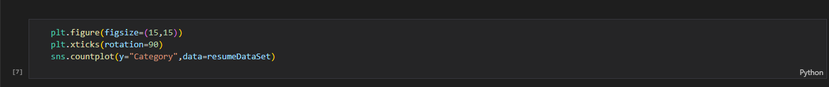

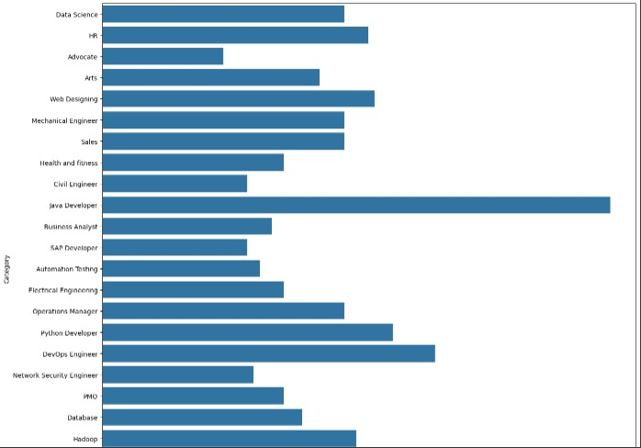

**4.1 Logistic Regression**

In our resume classification project, Logistic Regression served as a fundamental component in categorizing resumes into distinct job categories based on their textual content. We began by preprocessing the resume data, eliminating extraneous details such as URLs, special characters, and stopwords to ensure that only relevant information was considered. Subsequently, we engineered features from the cleaned resumes using TF-IDF vectorization, converting the text data into numerical representations that captured the significance of each word relative to the entire dataset. These TF-IDF features formed the basis for training the Logistic Regression model.

We divided the dataset into training and testing sets, with the model learning the relationship between the TF-IDF features and the corresponding job categories during training. By utilizing the logistic function to model the probability of each resume belonging to a specific category, the Logistic Regression model was able to effectively classify resumes. During evaluation, we assessed the model's performance on the testing set using metrics such as accuracy, precision, recall, and F1-score, ensuring its effectiveness in accurately categorizing resumes.

Once the model demonstrated satisfactory performance, it was deployed in the production environment and integrated into the resume classification system, where it could automatically categorize incoming resumes into appropriate job categories based on their content. Overall, Logistic Regression played a crucial role in streamlining the resume classification process, providing an interpretable and efficient algorithm

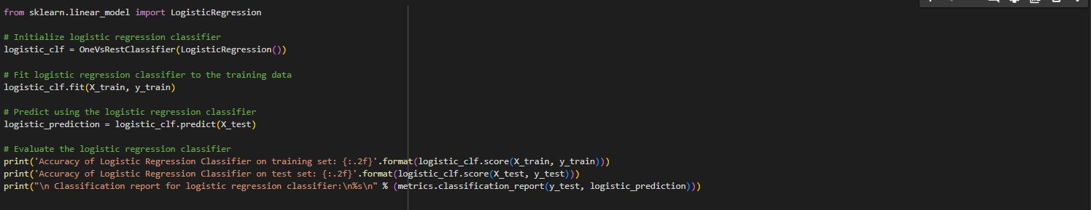

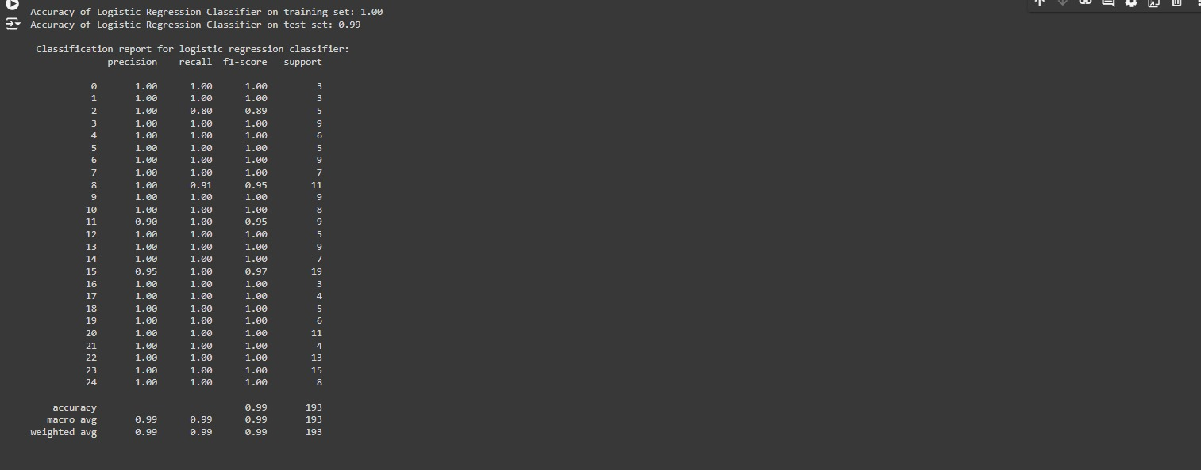

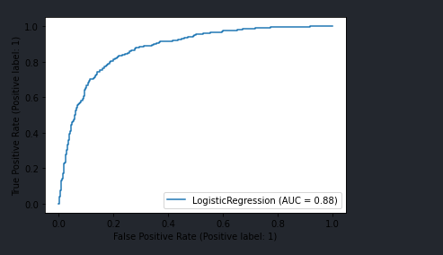

**Accuracy of Logistic regression model is 0.99%**

**4.2 Support Vector Machine(SVM)**

In the framework of our resume classification project, Support Vector Machine (SVM) served as a key algorithmic tool for categorizing resumes into specific job categories based on their textual content. We commenced by preprocessing the resume data, which involved eliminating extraneous details such as URLs, special characters, and stopwords to ensure the focus remained solely on relevant information. Following this, we engineered features from the cleaned resumes using TF-IDF vectorization, a technique that transformed the text data into numerical representations capturing the importance of each word relative to the entire dataset. These TF-IDF features formed the basis for training the SVM model.

We partitioned the dataset into training and testing sets, enabling the model to learn the intricate relationships between the TF-IDF features and the corresponding job categories during the training phase. Leveraging its ability to identify the optimal hyperplane that best separates the data points into different classes, SVM effectively classified resumes. During evaluation, we rigorously assessed the model's performance on the testing set using metrics such as accuracy, precision, recall, and F1-score to ensure its efficacy in accurately categorizing resumes.

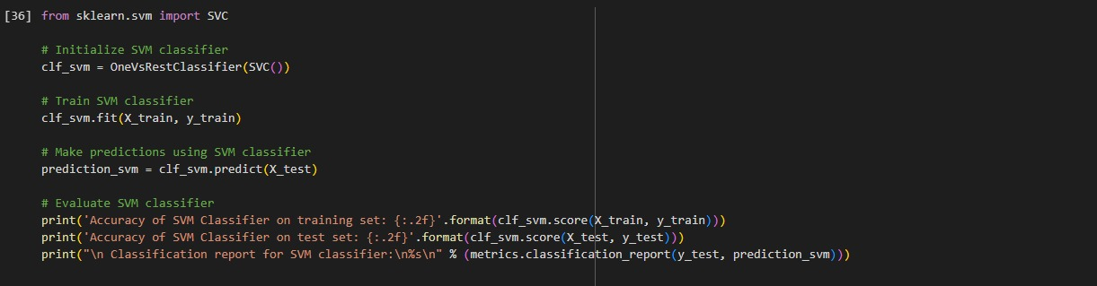Once the model demonstrated satisfactory performance, it was seamlessly deployed in the production environment and integrated into the resume classification system, where it autonomously categorized incoming resumes into appropriate job categories based on their content. Overall, SVM played a pivotal role in enhancing the efficiency and accuracy of the resume classification process, providing a robust algorithmic approach for organizing resumes according to their relevant job categories.

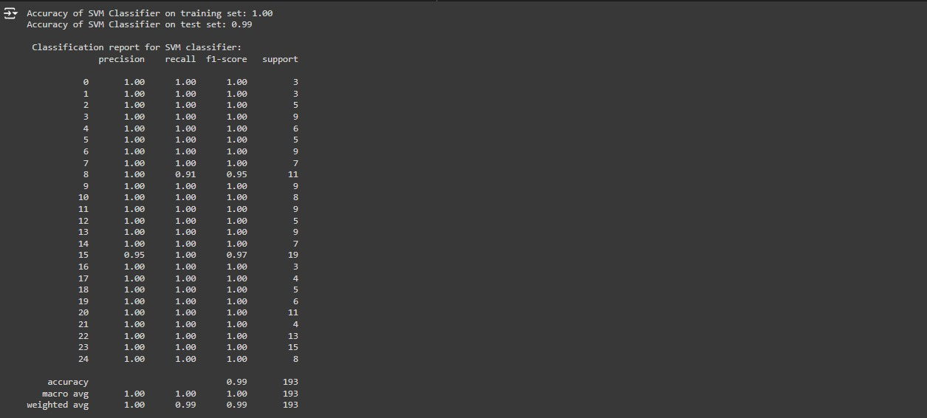

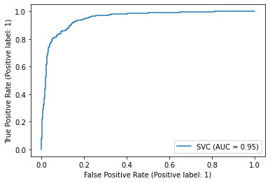

Accuracy of Support Vector Classification is 0.99 %

**4.3 Decision Tree Classifier**

In the context of our resume classification project, Decision Tree emerged as a crucial algorithmic tool for categorizing resumes into specific job categories based on their textual content. The process began with the preprocessing of the resume data, where we meticulously removed extraneous details such as URLs, special characters, and stopwords to focus solely on pertinent information. Subsequently, we engineered features from the cleaned resumes using TF-IDF vectorization, a technique that transformed the text data into numerical representations capturing the significance of each word relative to the entire dataset. These TF-IDF features were instrumental in training the Decision Tree model.

The dataset was partitioned into training and testing sets, allowing the model to learn the intricate relationships between the TF-IDF features and the corresponding job categories during the training phase. Utilizing its ability to recursively split the dataset based on the feature that best separates the data into pure or nearly pure subsets, Decision Tree effectively classified resumes. During evaluation, we rigorously assessed the model's performance on the testing set using metrics such as accuracy, precision, recall, and F1-score to ensure its efficacy in accurately categorizing resumes. Once the model demonstrated satisfactory performance, it was seamlessly deployed in the production environment and integrated into the resume classification system, where it autonomously categorized incoming resumes into appropriate job categories based on their content.

Decision Tree offered several distinct advantages in our project. Its inherent simplicity and interpretability made it particularly valuable, as it provided clear insights into the decision-making process of the model. This transparency not only facilitated a deeper understanding of how resumes were being classified but also enabled us to identify important features driving the classification decisions. Moreover, Decision Tree's ability to handle both numerical and categorical data allowed us to efficiently incorporate various types of information present in resumes, including skills, experience, and education background. Overall, Decision Tree played a pivotal role in enhancing the efficiency and accuracy of the resume classification process, providing an intuitive and interpretable algorithmic approach for organizing resumes according to their relevant job categories.

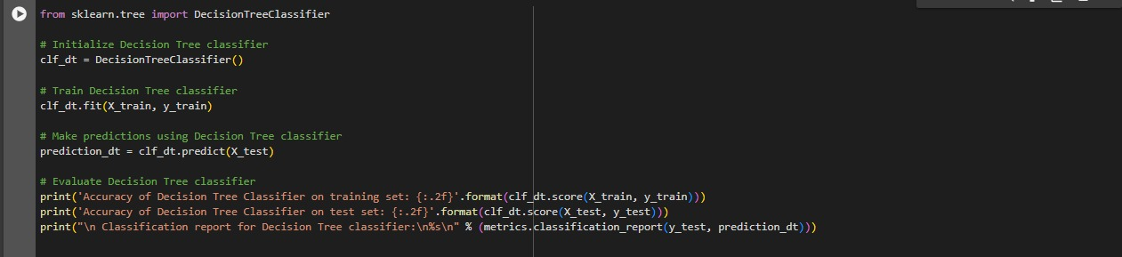

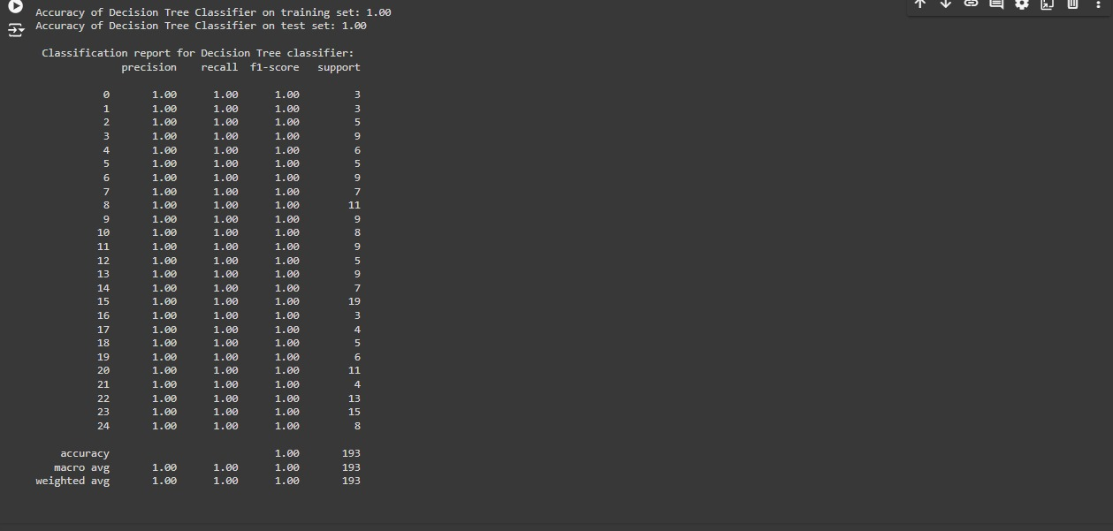

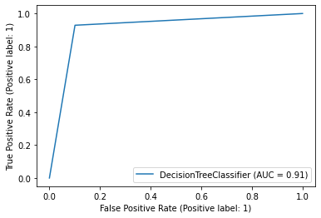

Accuracy of Decision Tree Classification is 1.00%.

**5. Reference**

1. DataSet – https://www.kaggle.com/datasets/gauravduttakiit/resume-dataset

2. Logistic Regression - https://www.geeksforgeeks.org/understanding-logistic-regression/

3. Decision Tree - https://www.geeksforgeeks.org/decision-tree/.